**Java installation**

**Double click -**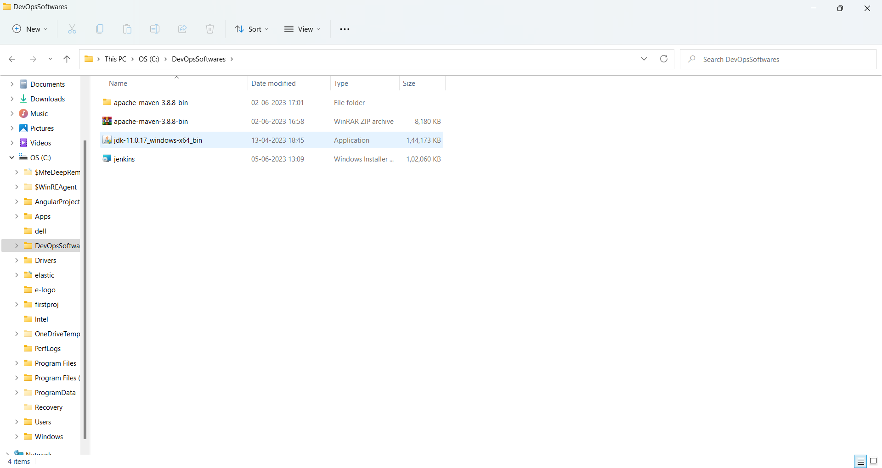

**Jdk-11.0.17_windows-x64_bin**

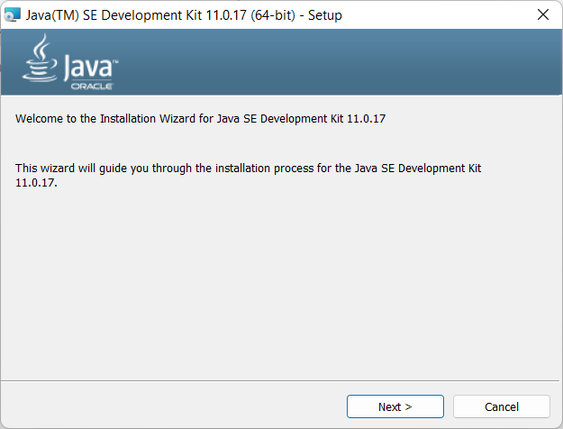

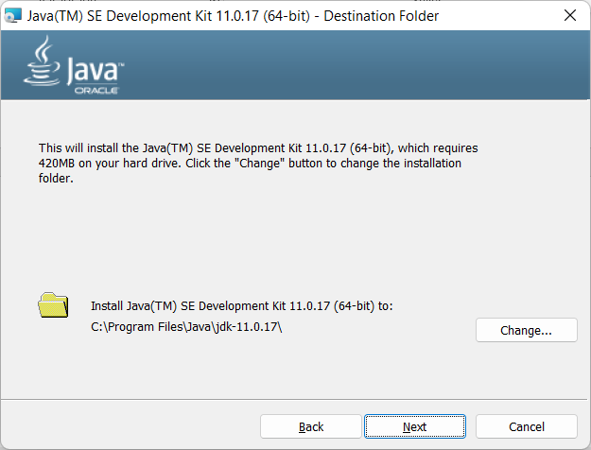

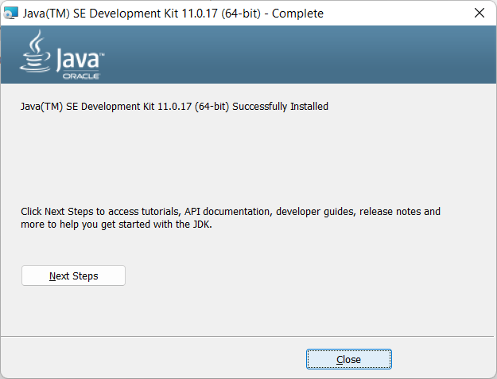

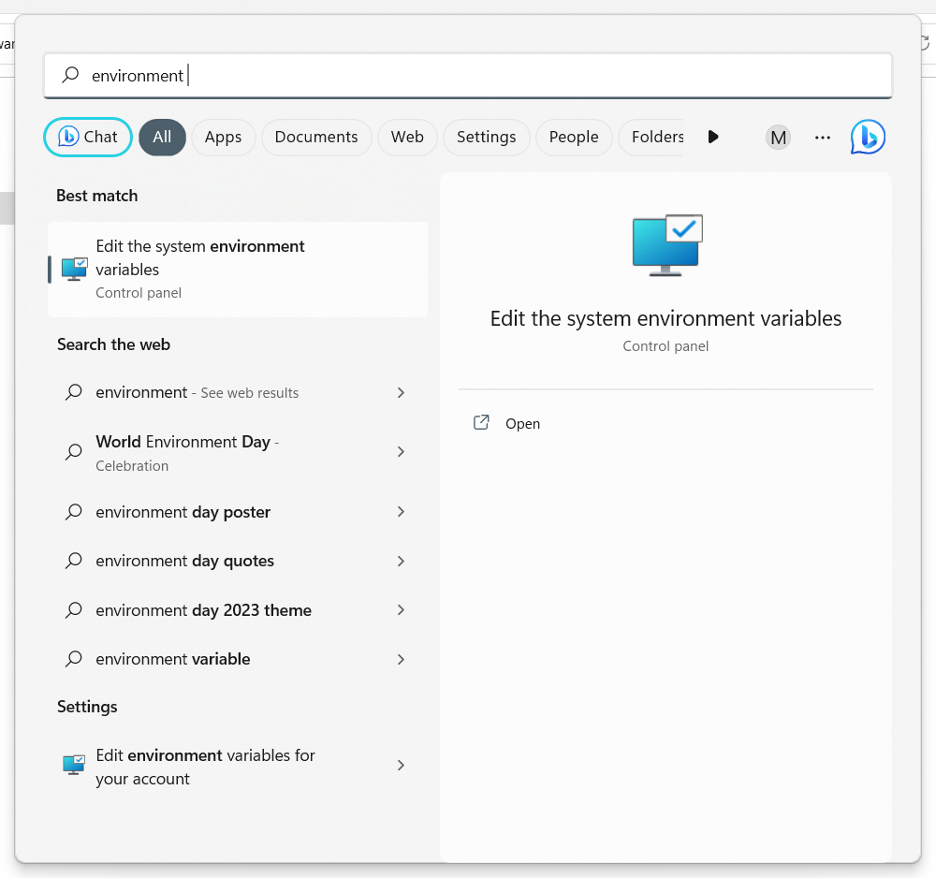

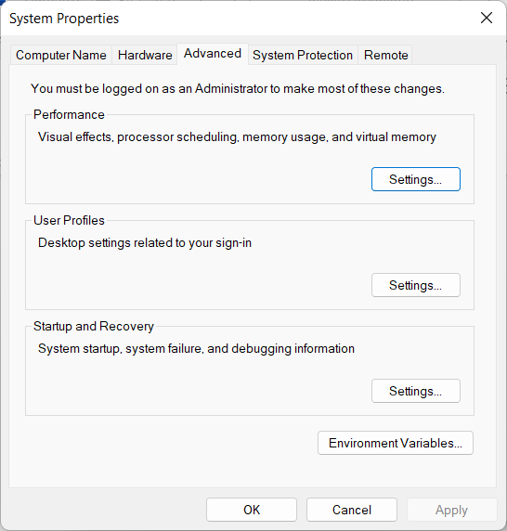

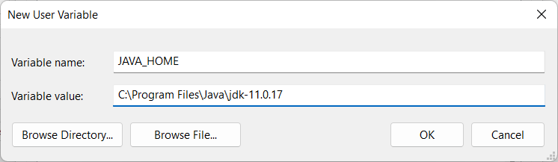

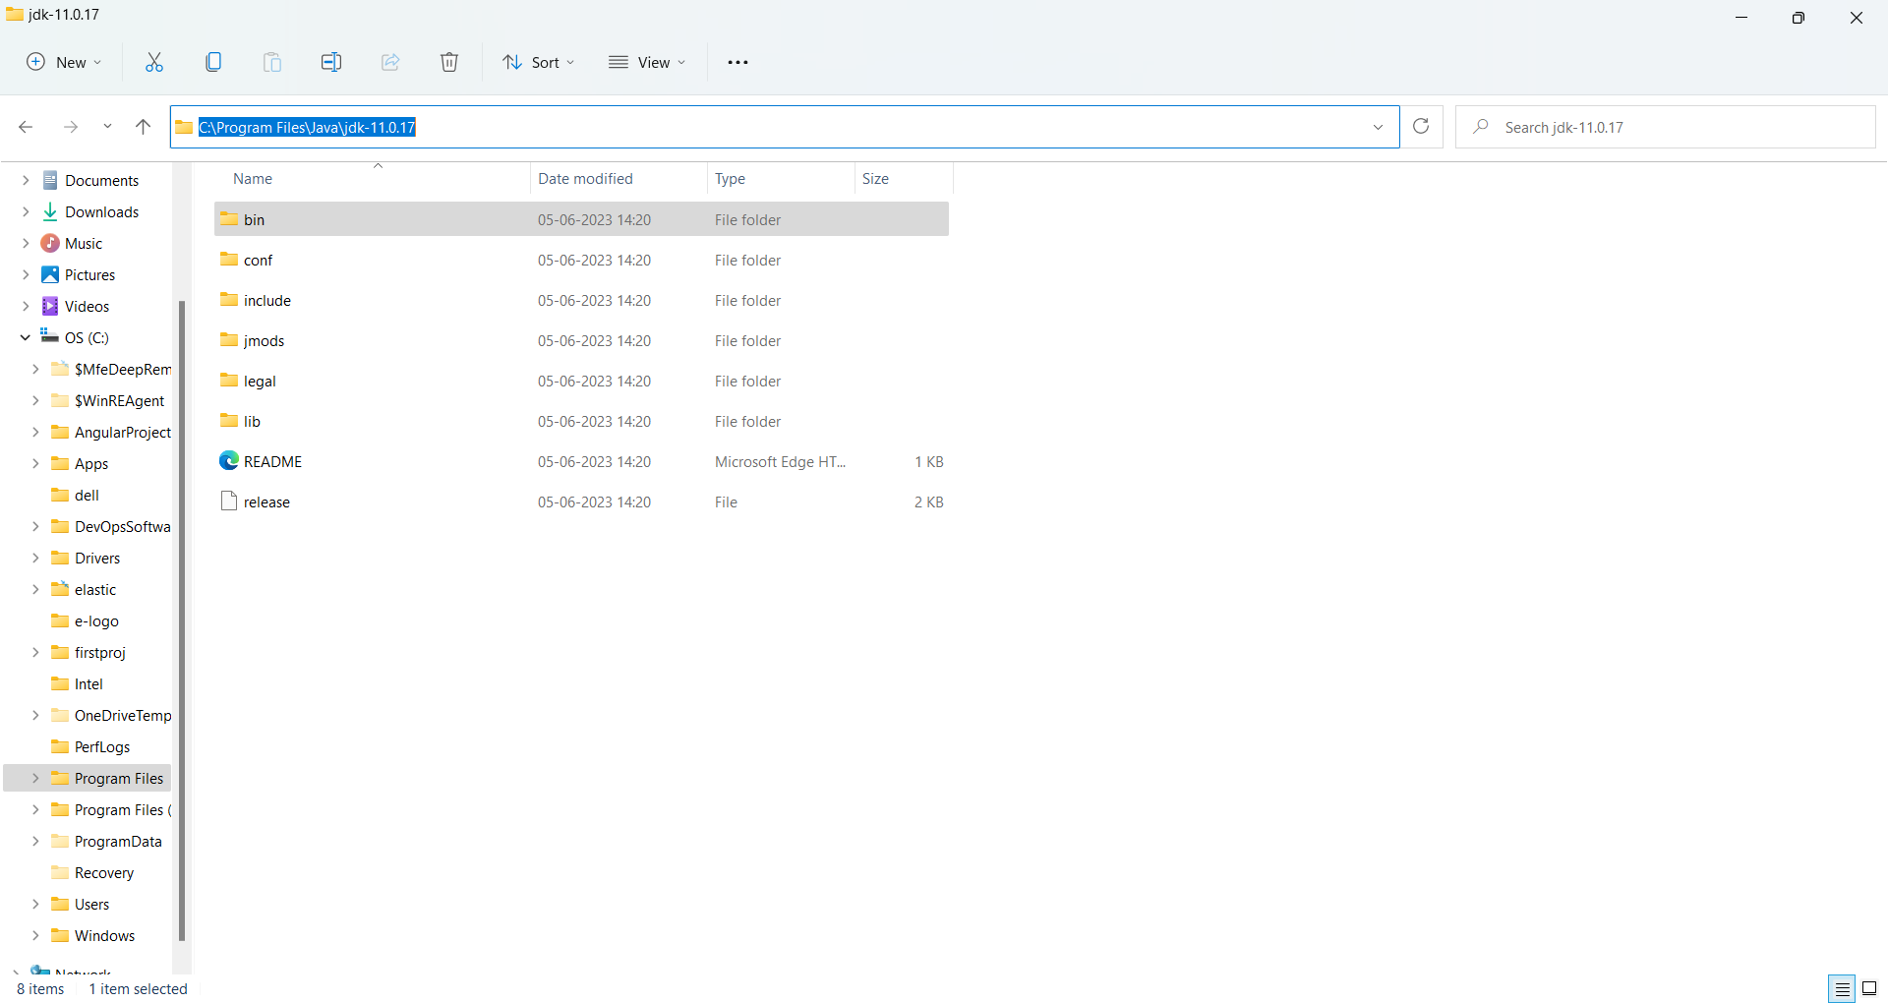

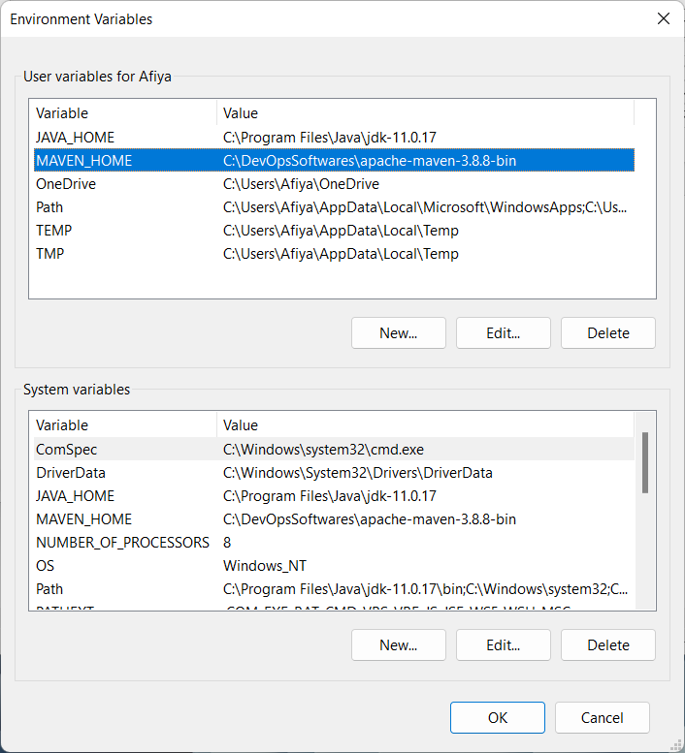

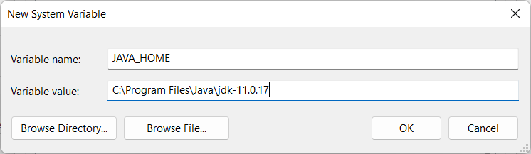

**Add this both on top and bottom**

**Add path variable**

**Double click on path**

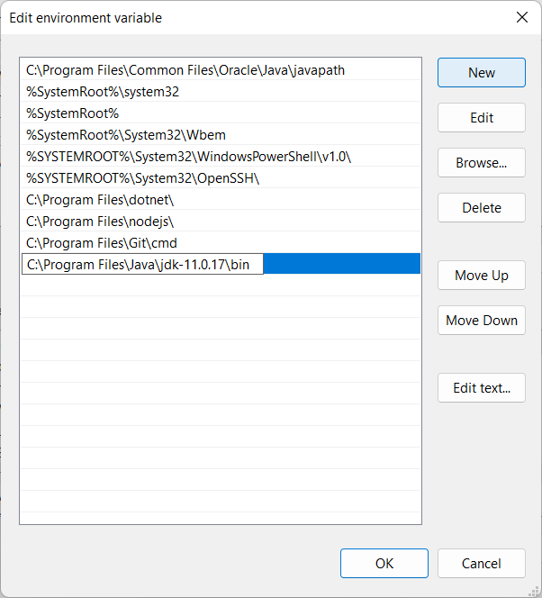 **add new**

**C:\Program Files\Java\jdk-11.0.17\bin**

**Maven Installation**

**Go to this site-https://maven.apache.org/download.cgi**

**Download this one-**Binary zip archive – for windows.

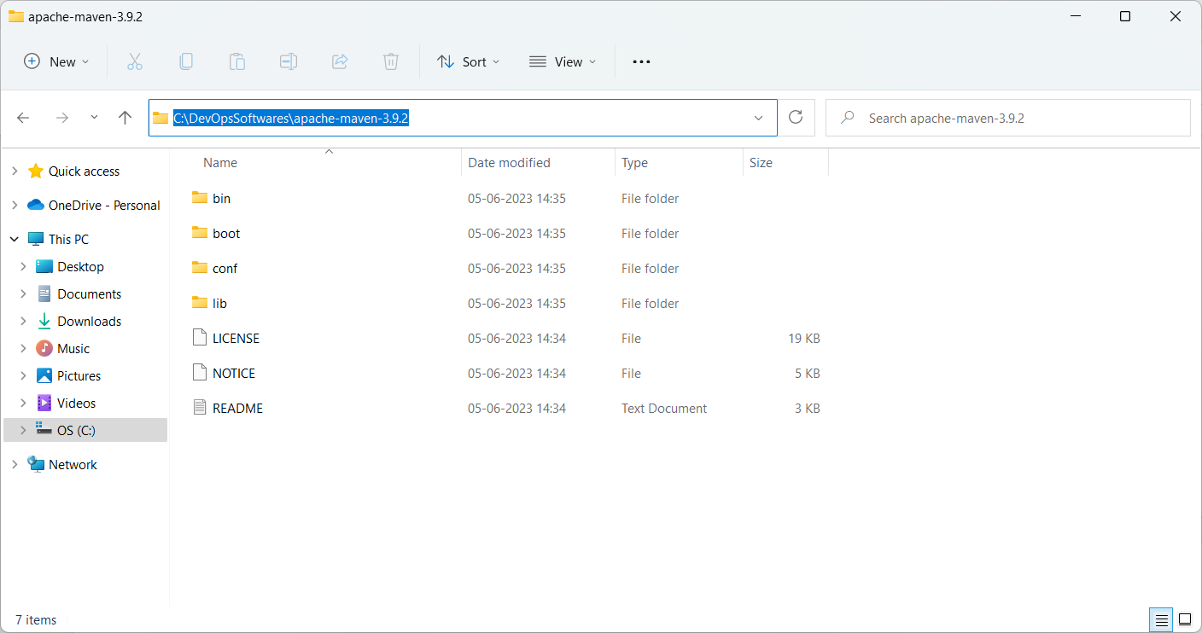

Add environment variavle

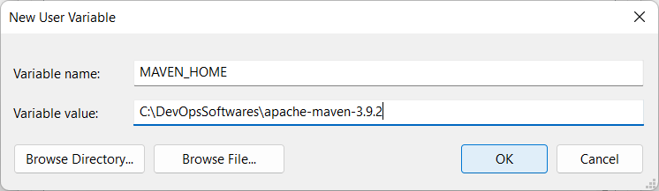

Add path

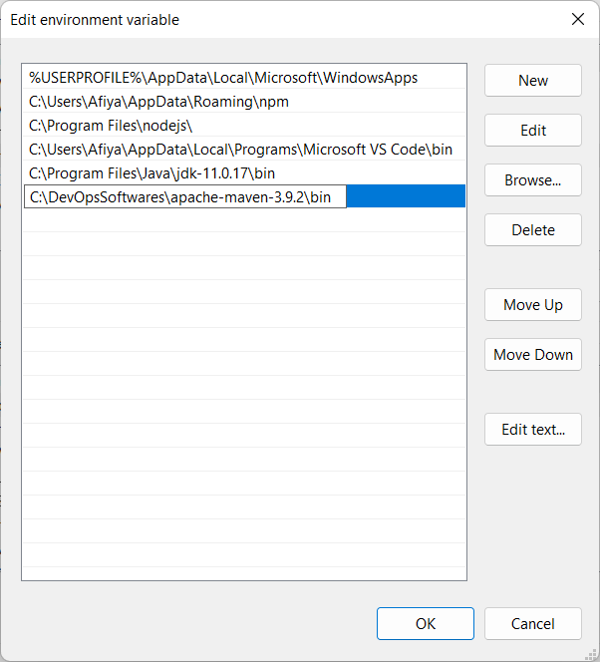

Extract the files

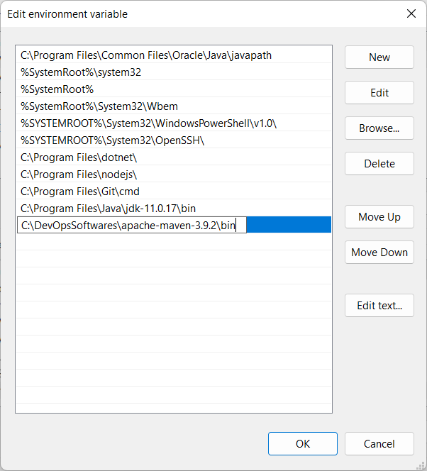

**Jenkins installation**

<https://www.jenkins.io/download/>

**Stable (LTS)**

Long-Term Support (LTS) release baselines are chosen every 12 weeks from the stream of regular releases. Every 4 weeks we release stable releases which include bug and

#### Regular releases (Weekly)

This release line delivers bug fixes and new features rapidly to users and plugin developers who need them.

So will choose lts

Msi--- automatically installs a service and it will run whenever the system is started

War- will have to manually run the service using the command by going to the location where war file is saved

Run msi file

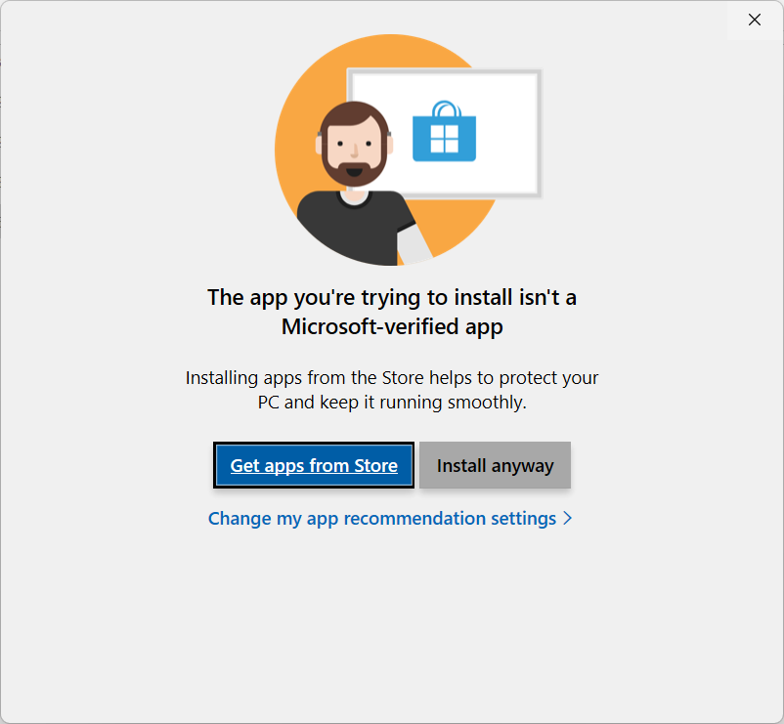

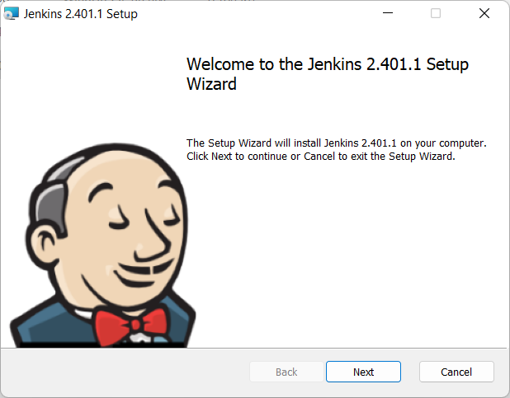

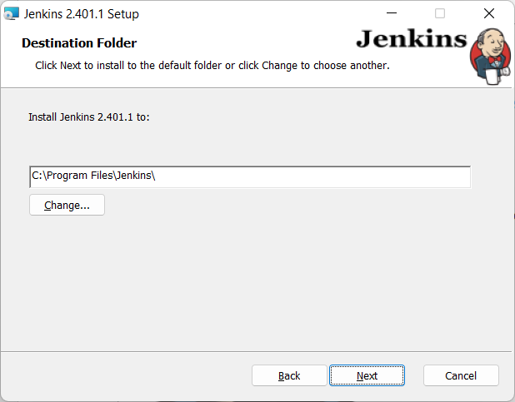

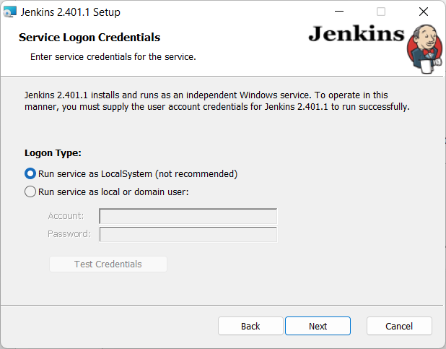

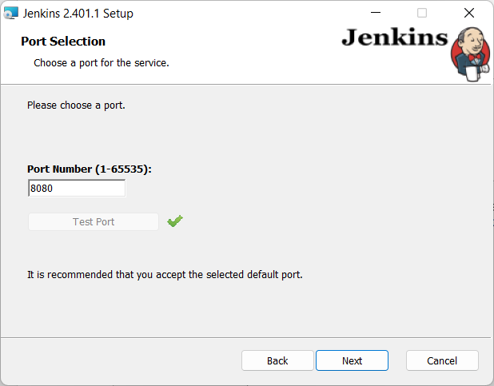

Checks the location where java (jdk) is stored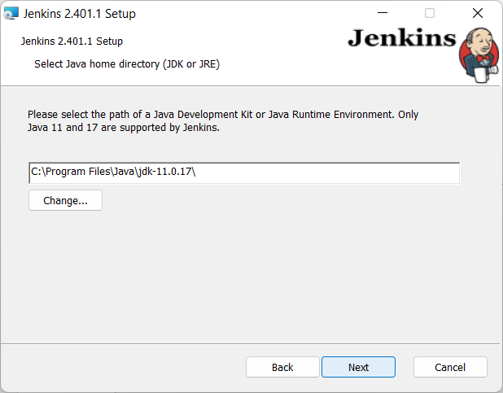

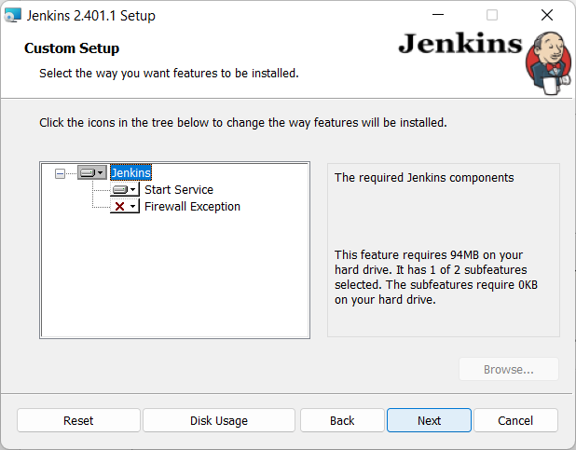

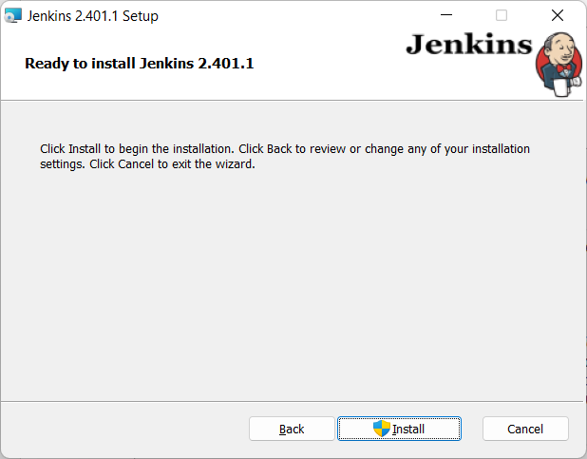

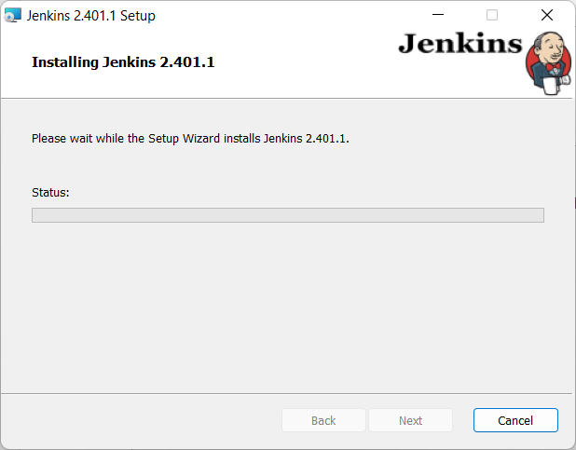

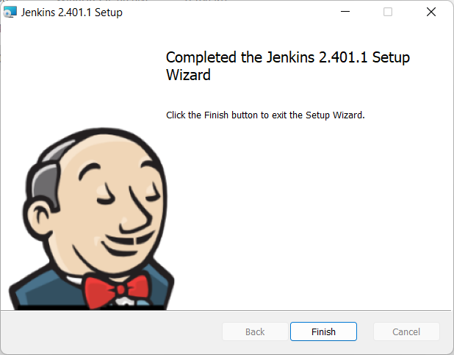

Go to browser

Localhost/8080

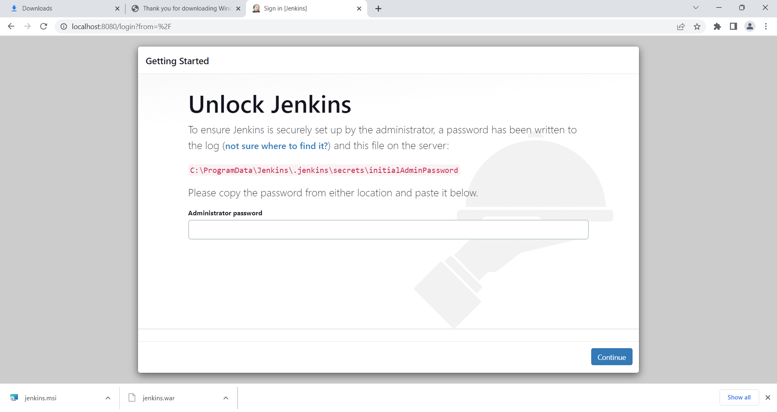

Copy the location-C:\ProgramData\Jenkins\.jenkins\secrets\initialAdminPassword

Here password will be stored

Go to this location open the notepad

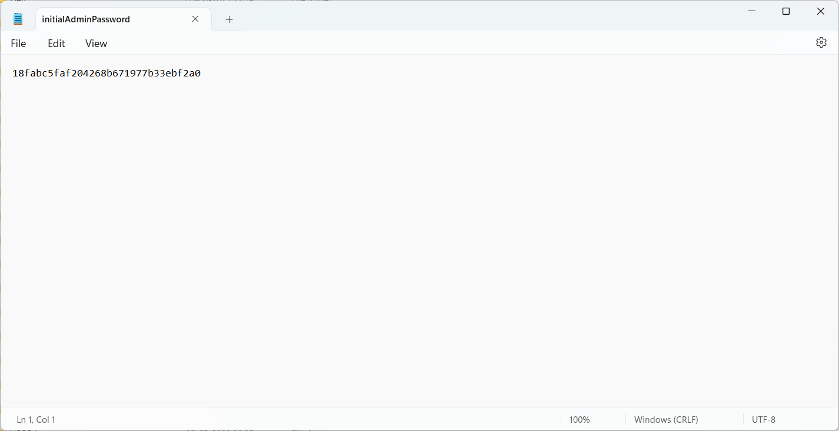

Copy the password

Paste in the browser

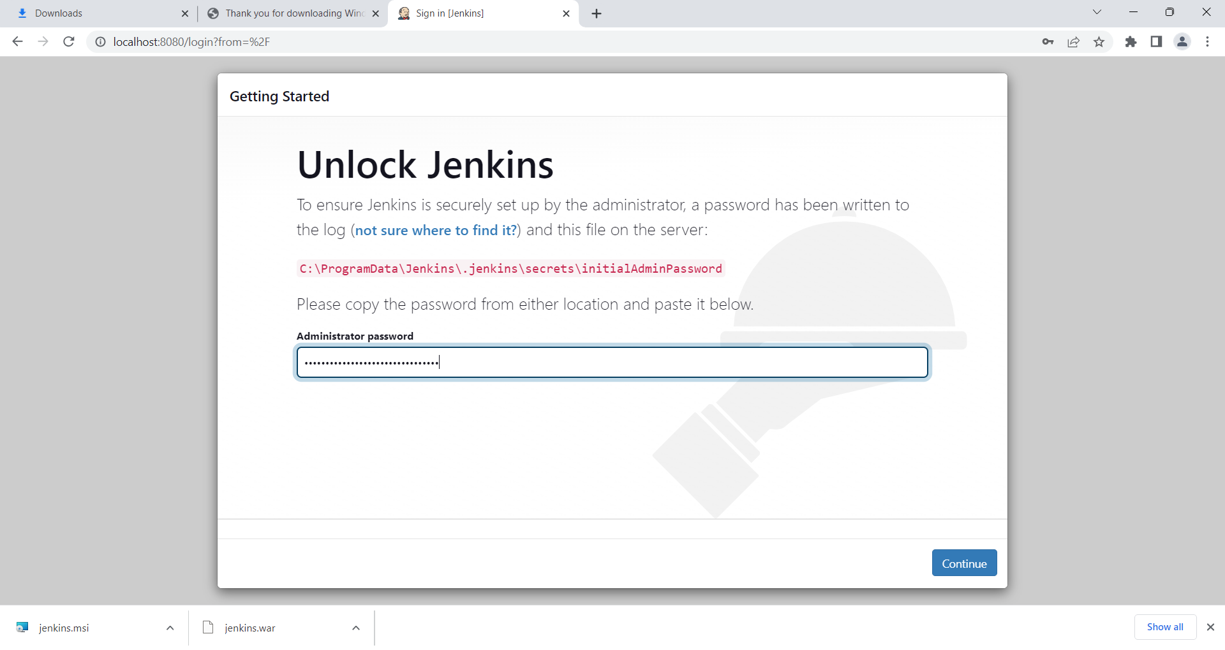

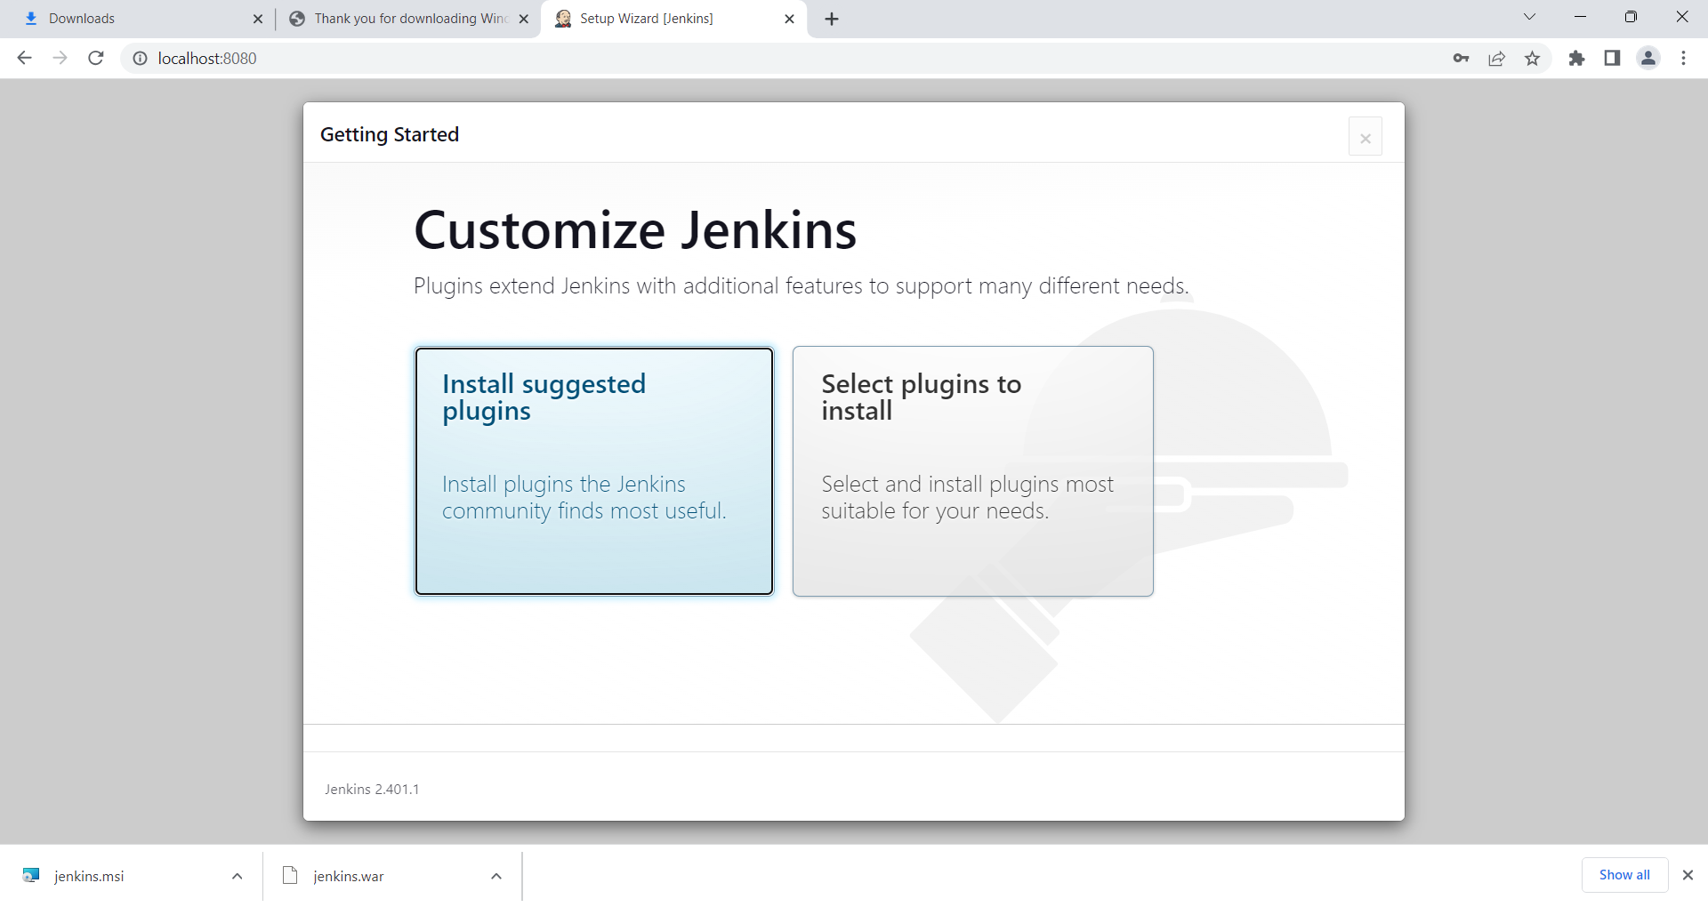 click on install suggested plugins

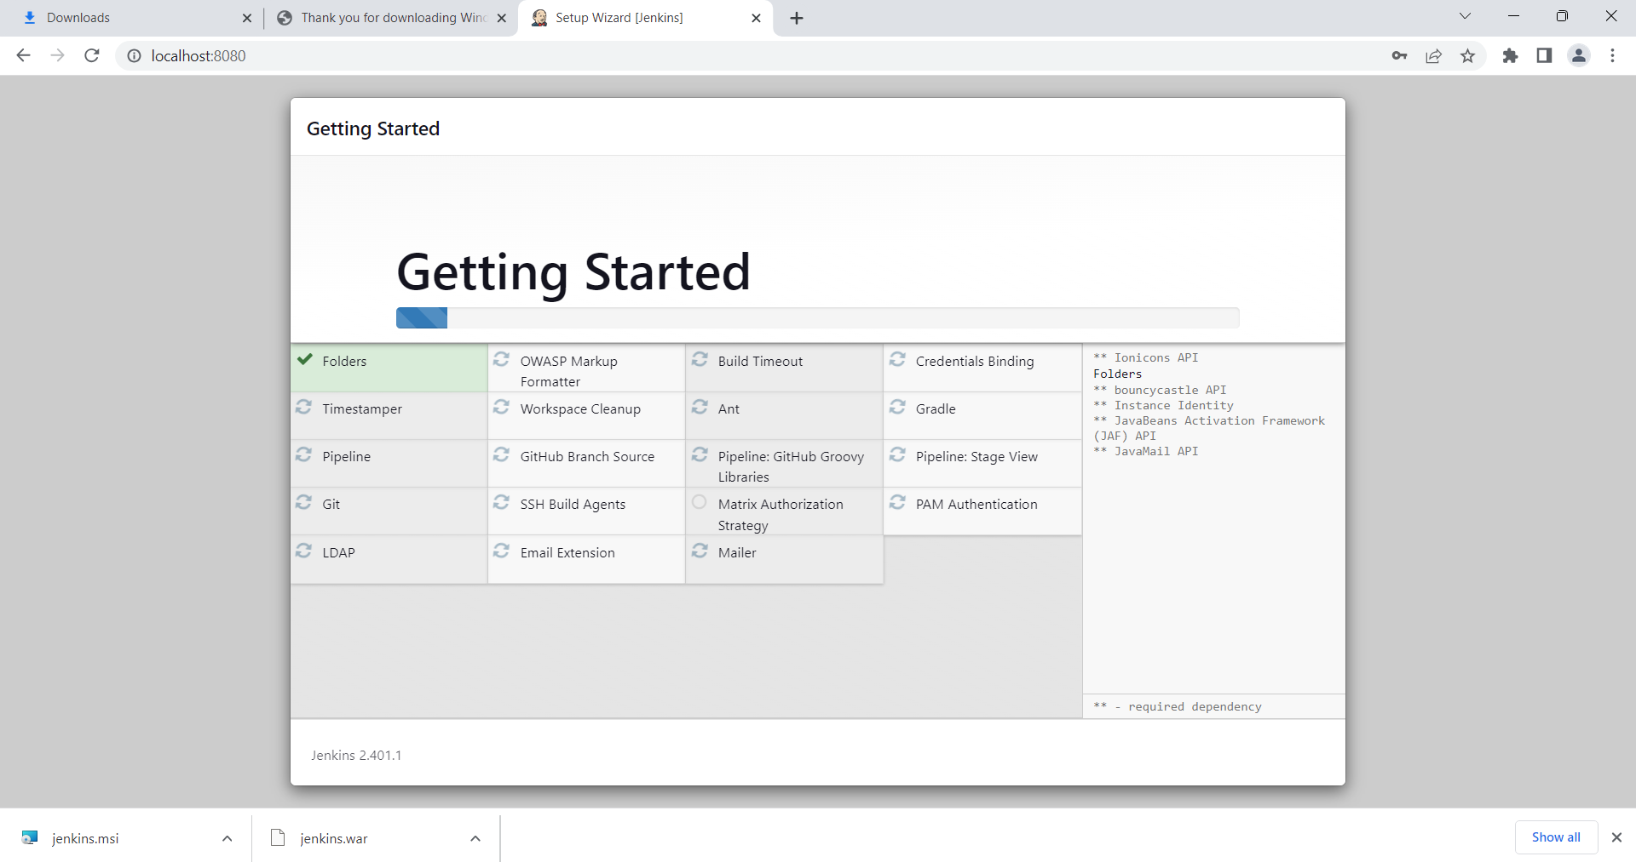

Click on retry,

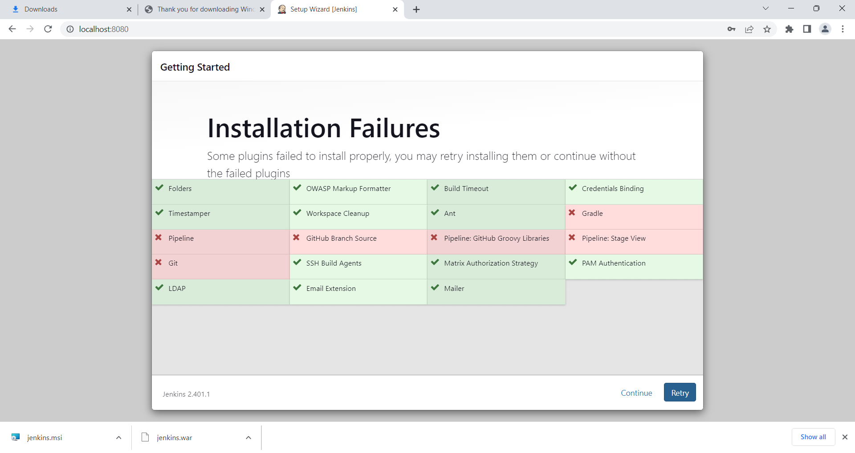

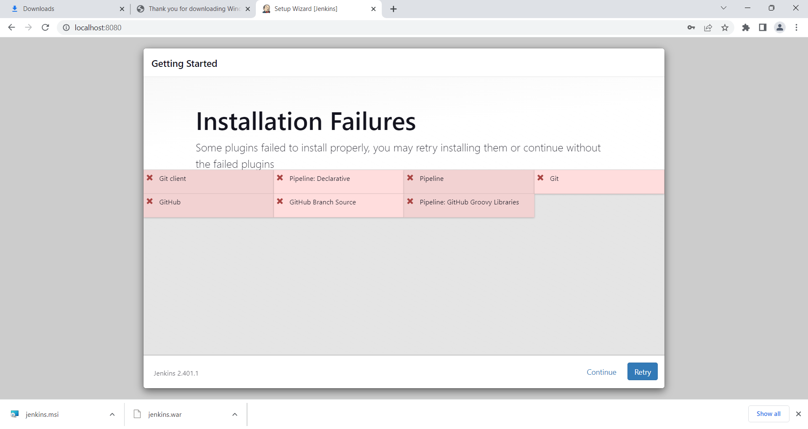

Click on continue.

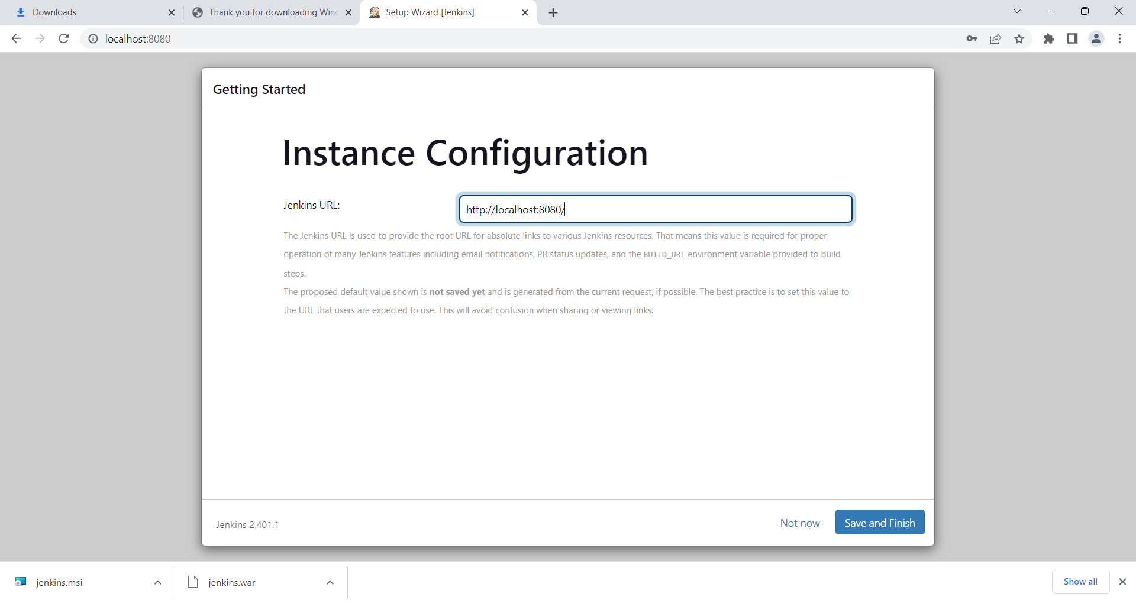

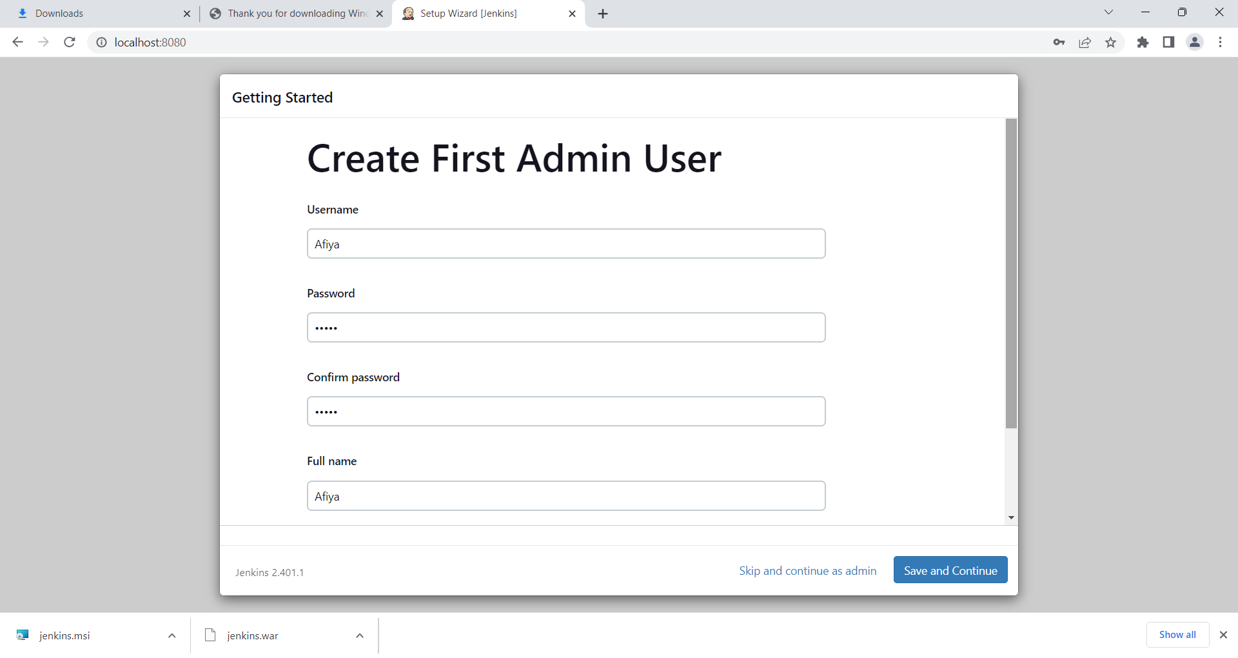

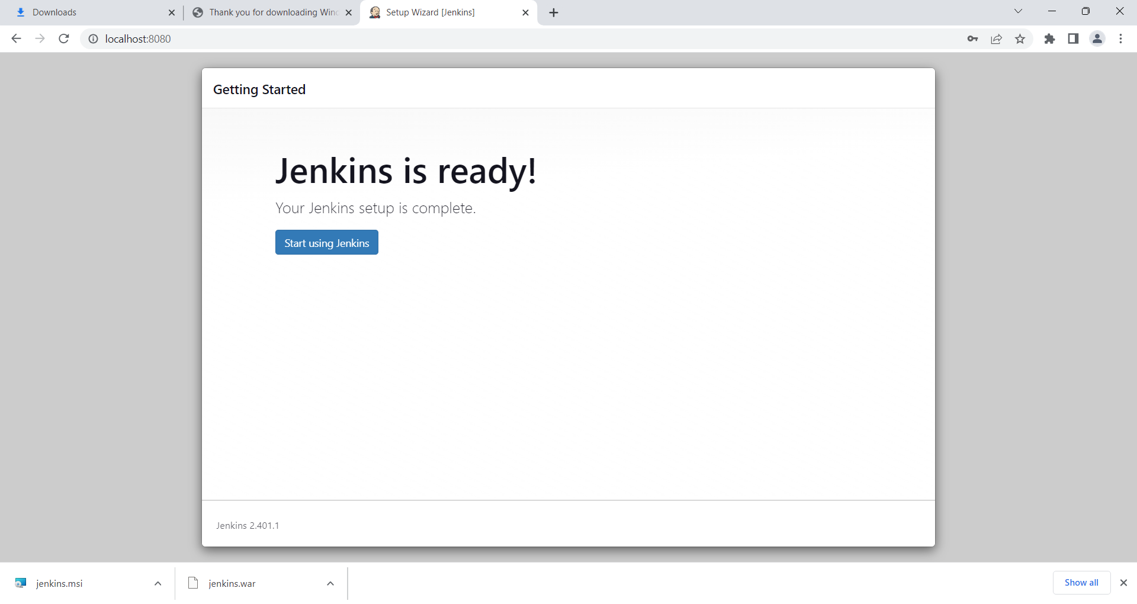

Start using Jenkins.

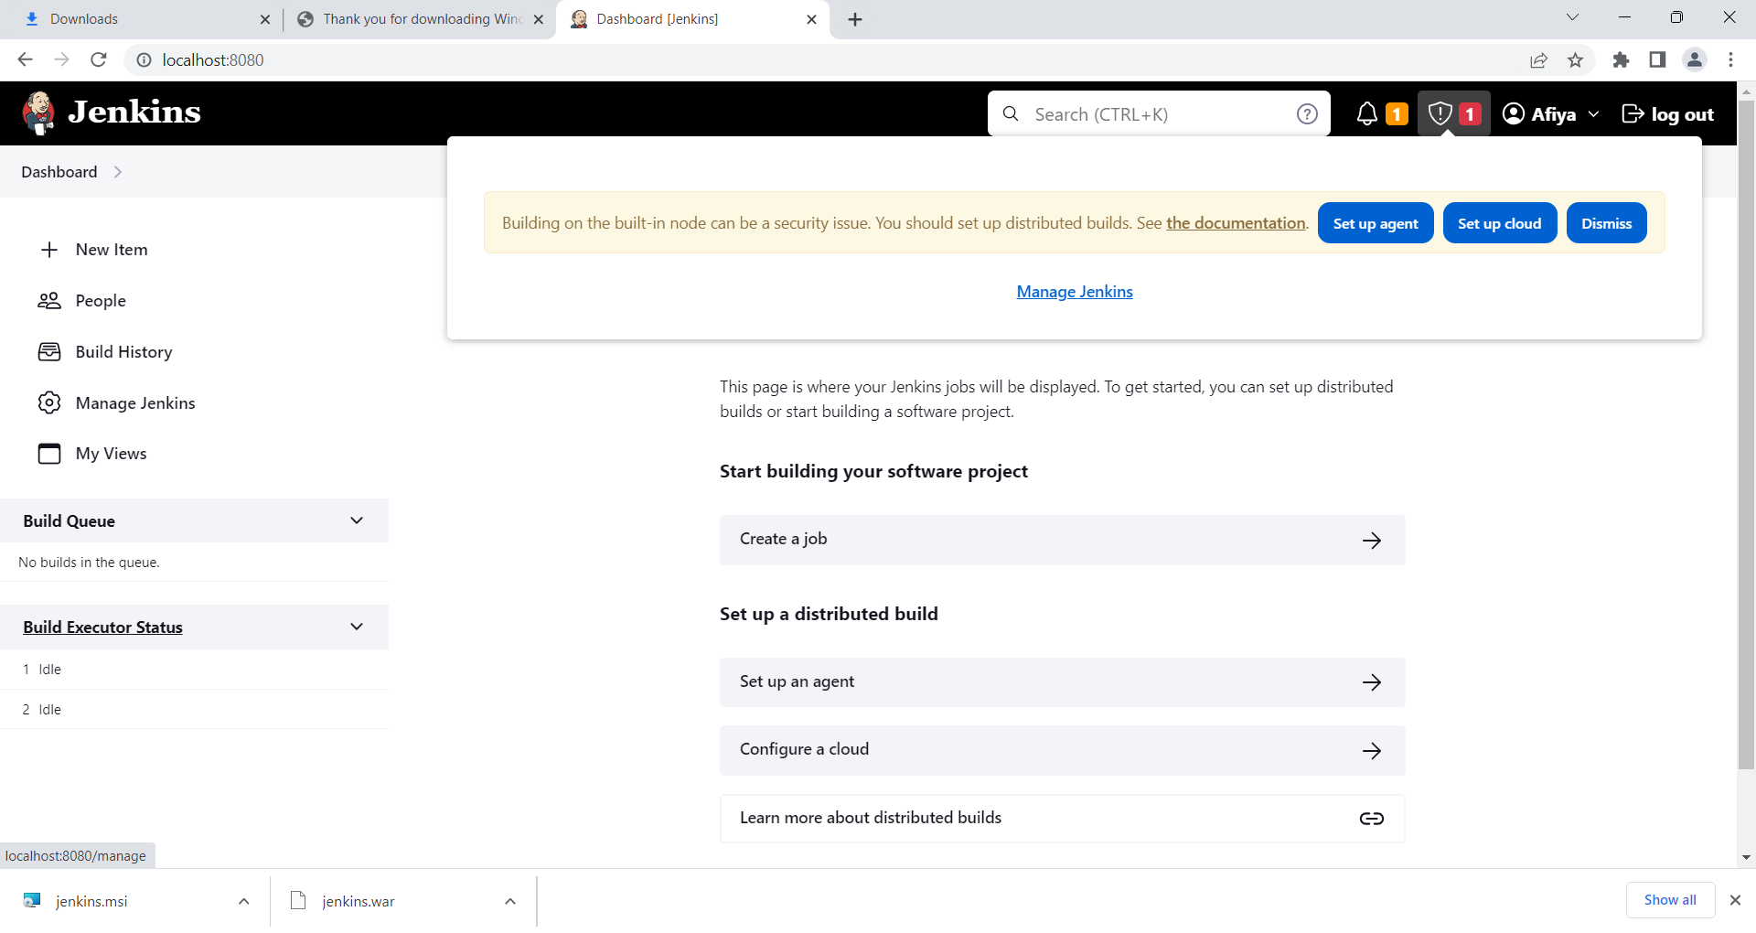

Click on manage Jenkins

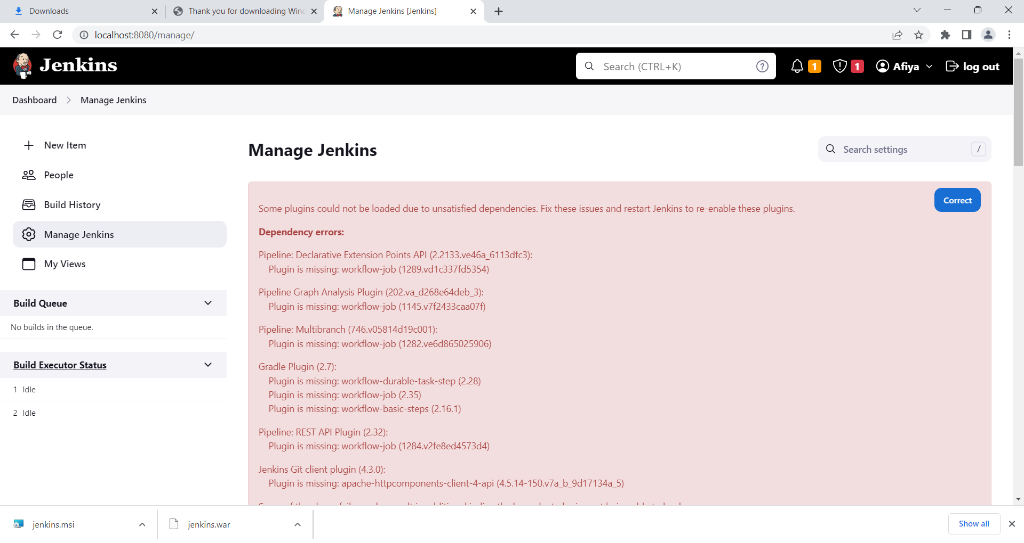

Click on correct .

If there is an installation failure after retry also then download the plugins via below wizard.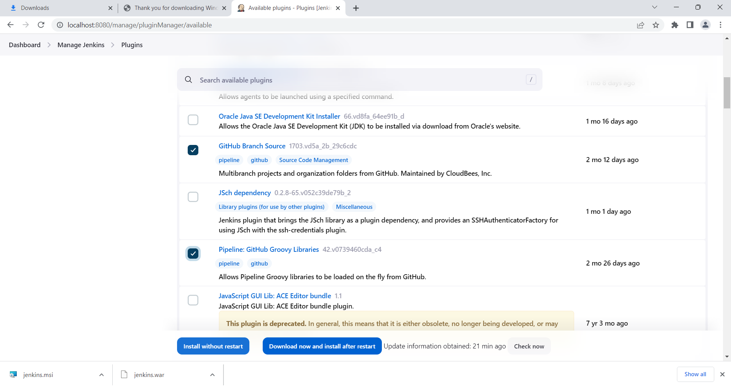

Click - Install without restart

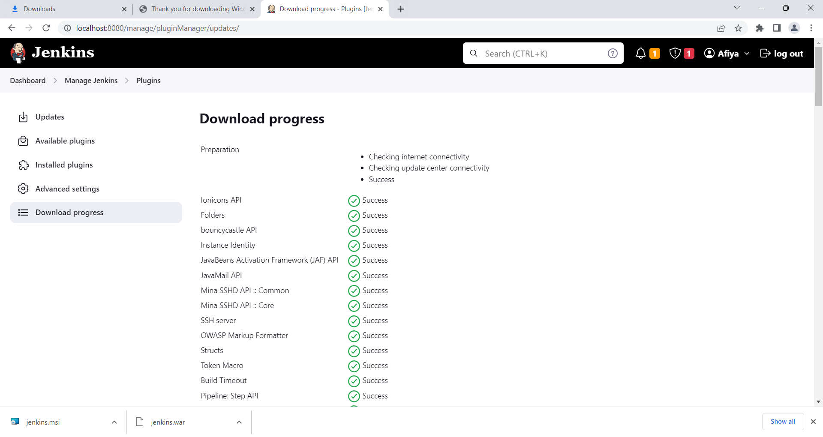

Installing docker compose

<https://dev.to/kylejschwartz/install-docker-compose-on-oracle-linux-8-1kb0>

installing elk in docker

docker ps

docker ps -a

git clone <https://github.com/deviantony/docker-elk.git>

cd docker-elk

<https://phoenixnap.com/kb/install-elk-stack-centos-8>

during vm creation – network – on select gui option disc select

sudo su

su root

reboot systemctl

remember : while installing remember to click gui

curl or mirror – problem

9200